

**MEMORANDUM OF UNDERSTANDING**

This is a document validating an agreement between **MR. OGABOR JOHN AND MRS. OLOLADE REDANI** for the collaborative of 20% interest over a sum of **TWO HUNDRED THOUSAND NAIRA ONLY (₦200,000) paid on the 03rd of June, 2020.**

There is a binding agreement to pay the initial capital invested, alongside the interest, **TWO HUNDRED AND FORTY THOUSAND NAIRA ONLY (₦240,000) on the 04th of July, 2020** by **MR. OGABOR JOHN TO MRS. OLOLADE REDANI.**

Attached with this document is an evidence of payment by **MRS. OLOLADE REDANI.**

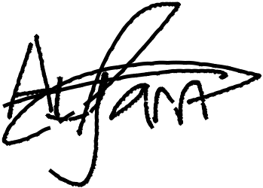

_________________________

_~~__~~_____~~___~~_~~_~~___________



**MRS. OLOLADE REDANI**

**MR. OGABOR JOHN**

***(CEO, JOHN INVESTMENTS)***